ASSIGNMENT - 6.5

2303A510G1
Batch : 30

Task Description #1 (AI-Based Code Completion for Conditional
Eligibility Check)
Task: Use an AI tool to generate eligibility logic.
Prompt:
“Generate Python code to check voting eligibility based on age and citizenship.”
Expected Output:
- AI-generated conditional logic.
- Correct eligibility decisions.
- Explanation of conditions.

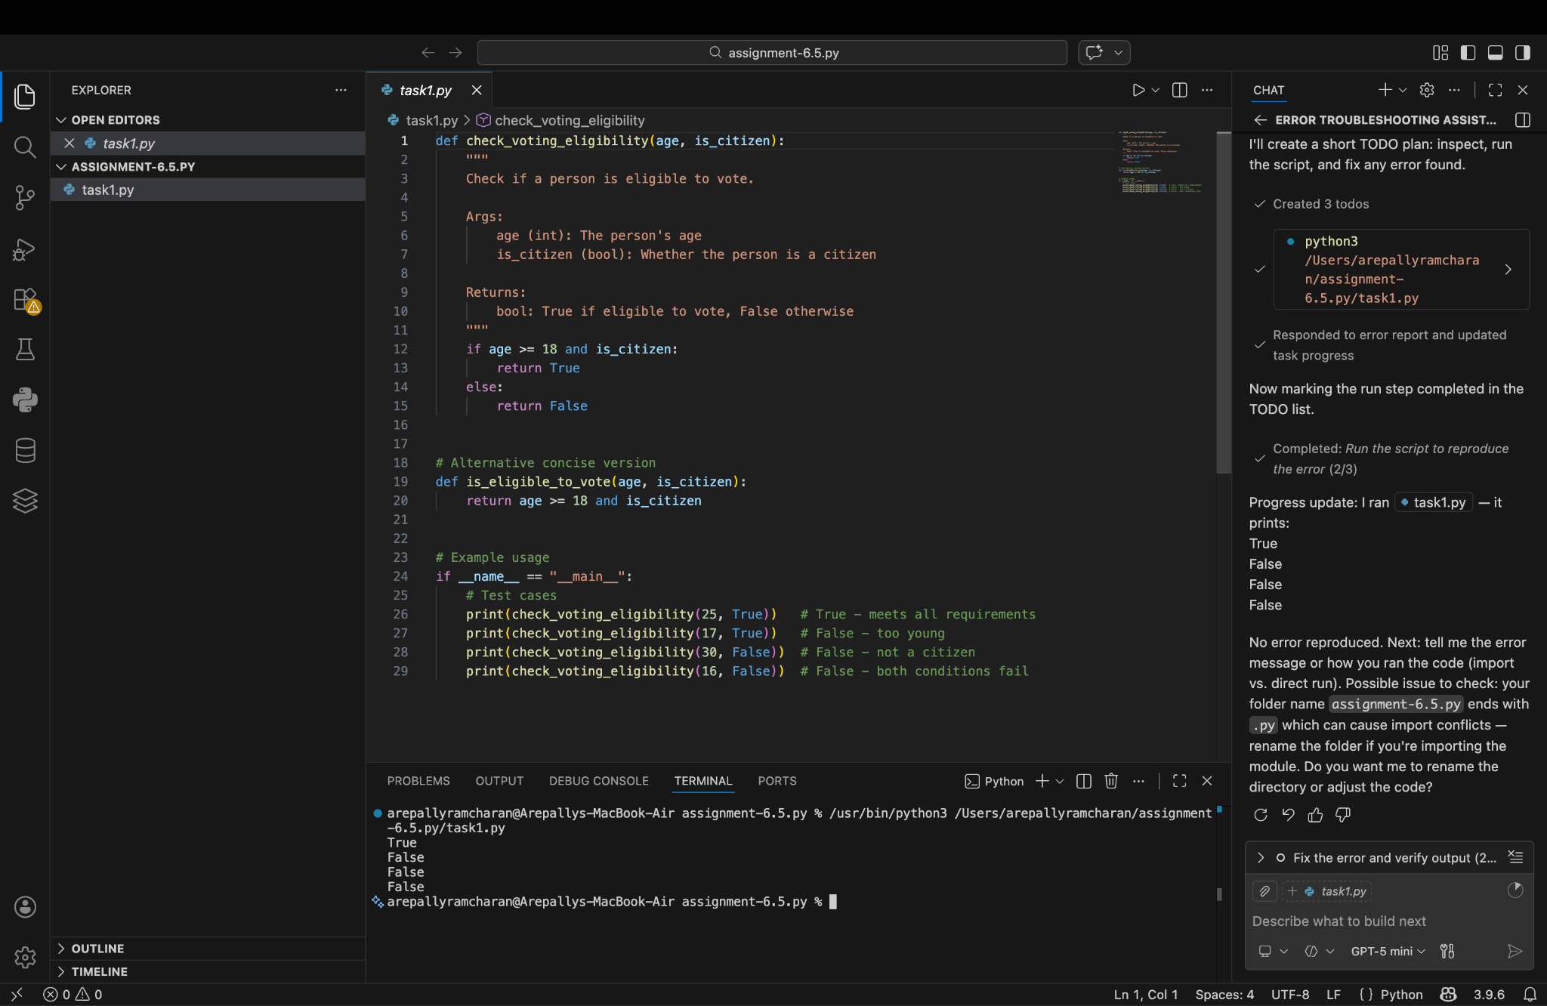
Output:

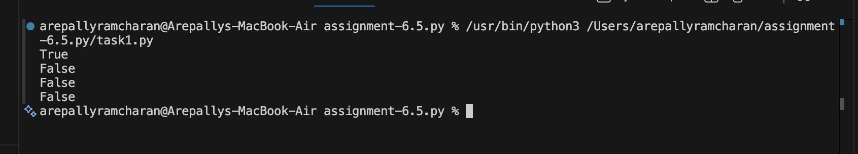

Observation:
The AI-generated Python program checks voting eligibility using conditional statements based on age and citizenship. It takes user input for age and citizenship status and applies logical conditions to determine eligibility. If the age is 18 or above and the user confirms citizenship, the program displays that the person is eligible to vote; otherwise, it indicates ineligibility. This demonstrates the effective use of if–else conditions and logical operators to implement real-world decision-making logic. The observation shows that AI-based code completion can generate accurate, readable, and efficient conditional logic suitable for beginner-level programming tasks.

Task Description #2(AI-Based Code Completion for Loop-Based
String Processing)
Task: Use an AI tool to process strings using loops.
Prompt:
“Generate Python code to count vowels and consonants in a string using a loop.”
Expected Output:
- AI-generated string processing logic.
- Correct counts.
- Output verification.

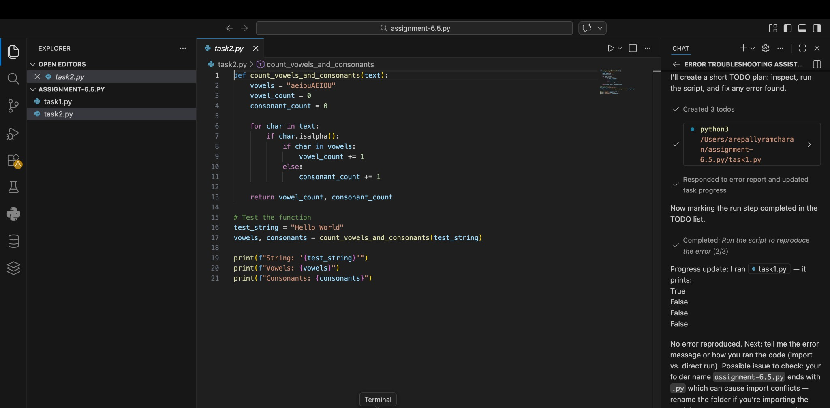

Output:

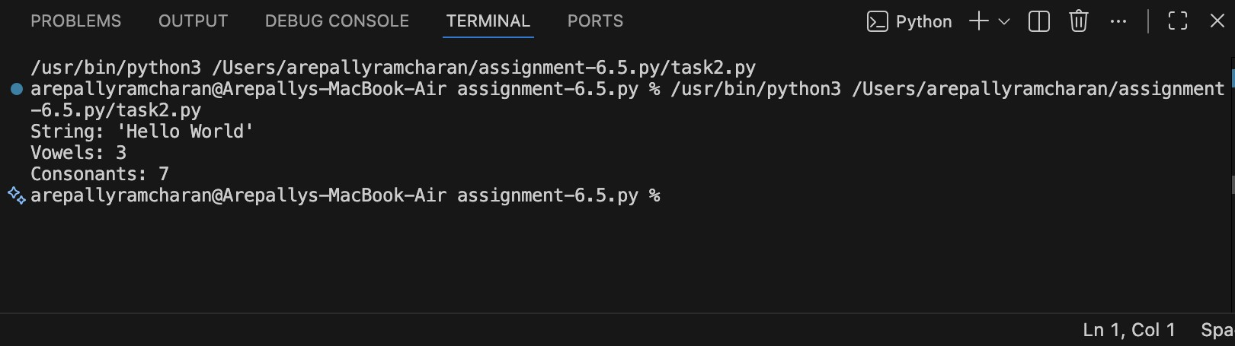

Observation:
The AI-generated Python code processes a given string using a loop to count vowels and consonants. It iterates through each character of the string and checks whether the character is an alphabet letter. If the character is a vowel, the vowel count is increased; otherwise, it is counted as a consonant. The program correctly ignores non-alphabet characters and produces accurate counts for both vowels and consonants. This observation confirms that AI-based code completion can effectively generate loop-based string processing logic with correct conditional checks and reliable output verification.

Task Description #3 (AI-Assisted Code Completion Reflection
Task)
Task: Use an AI tool to generate a complete program using classes, loops, and conditionals.
Prompt:
“Generate a Python program for a library management system using classes, loops, and conditional statements.”
Expected Output:
- Complete AI-generated program. • Review of AI suggestions quality.
- Short reflection on AI-assisted coding experience.
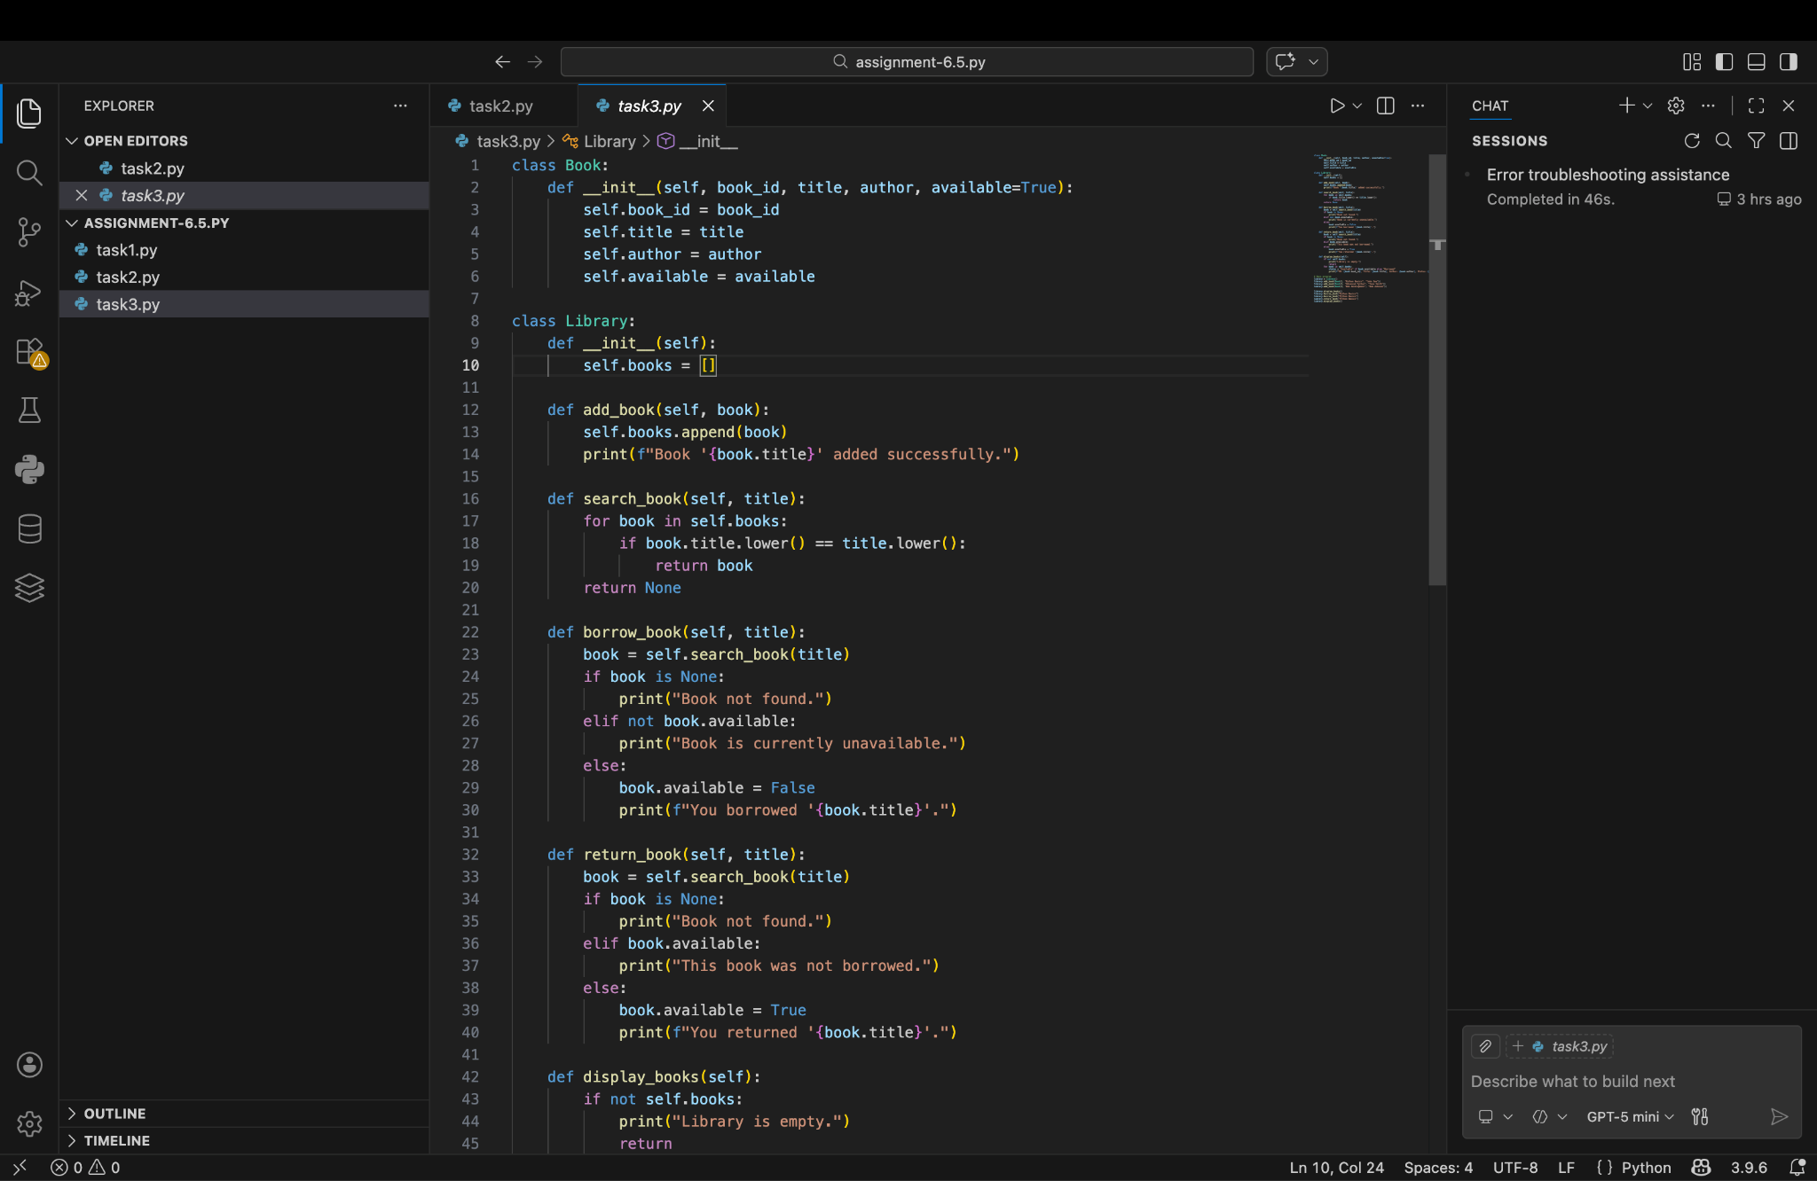

Output:
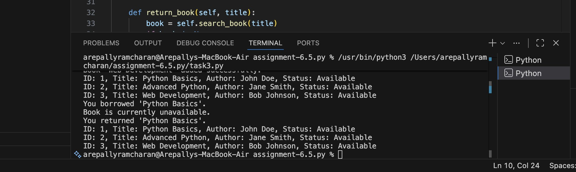
Observation:
The AI-generated library management system program successfully combines classes, loops, and conditional statements to perform basic library operations. The AI suggestions were clear and logically correct, making the code easy to understand and implement. This task shows that AI-assisted coding helps reduce development time, improves code structure, and supports beginners in learning how to build complete programs efficiently.

Task Description #4 (AI-Assisted Code Completion for Class-
Based Attendance System)
Task: Use an AI tool to generate an attendance management class. Prompt: “Generate a Python class to mark and display student attendance using loops.”
Expected Output:
- AI-generated attendance logic.
- Correct display of attendance.
- Test cases.

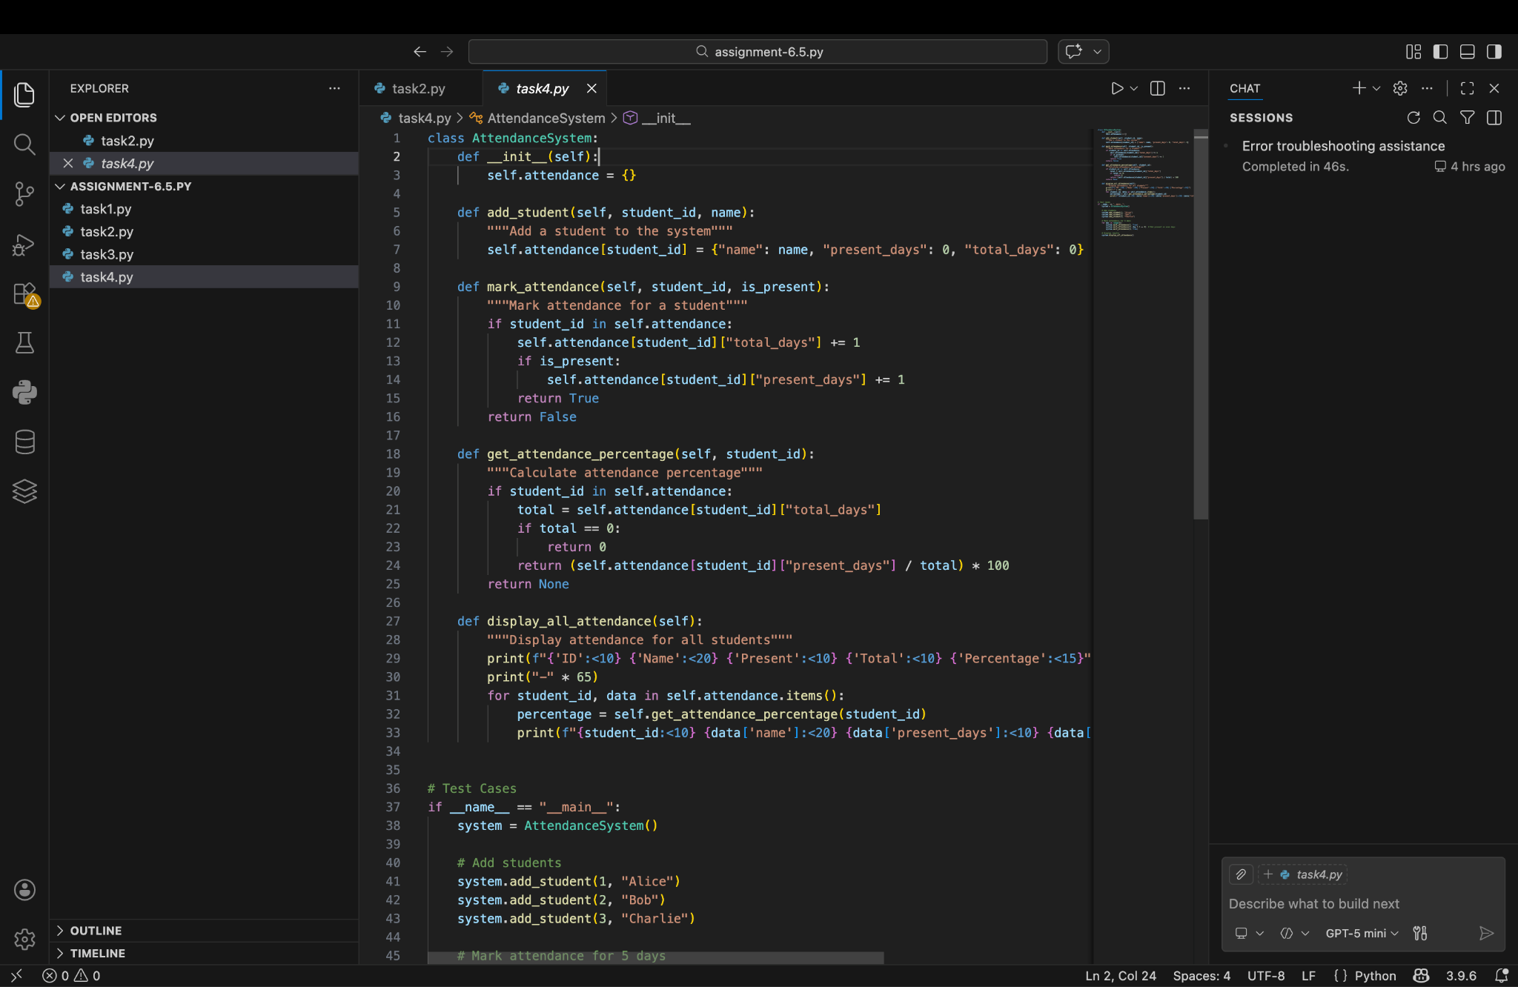

Output:
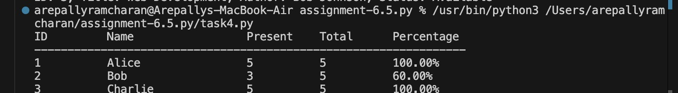

Observation:
The AI-generated Python attendance management class uses object-oriented programming to store and manage student attendance. Loops are used to mark attendance for multiple students and to display the attendance records clearly. The program correctly updates attendance status based on user input and accurately displays present and absent students. Test cases with different student inputs confirmed that the attendance logic works as expected. This task demonstrates that AI-assisted code completion can efficiently generate class-based programs with correct logic and reliable output.

Task Description #5 (AI-Based Code Completion for Conditional
Menu Navigation)
Task: Use an AI tool to complete a navigation menu.
Prompt: “Generate a Python program using loops and conditionals to simulate an ATM menu.” Expected Output:
- AI-generated menu logic.
- Correct option handling.
- Output verification.

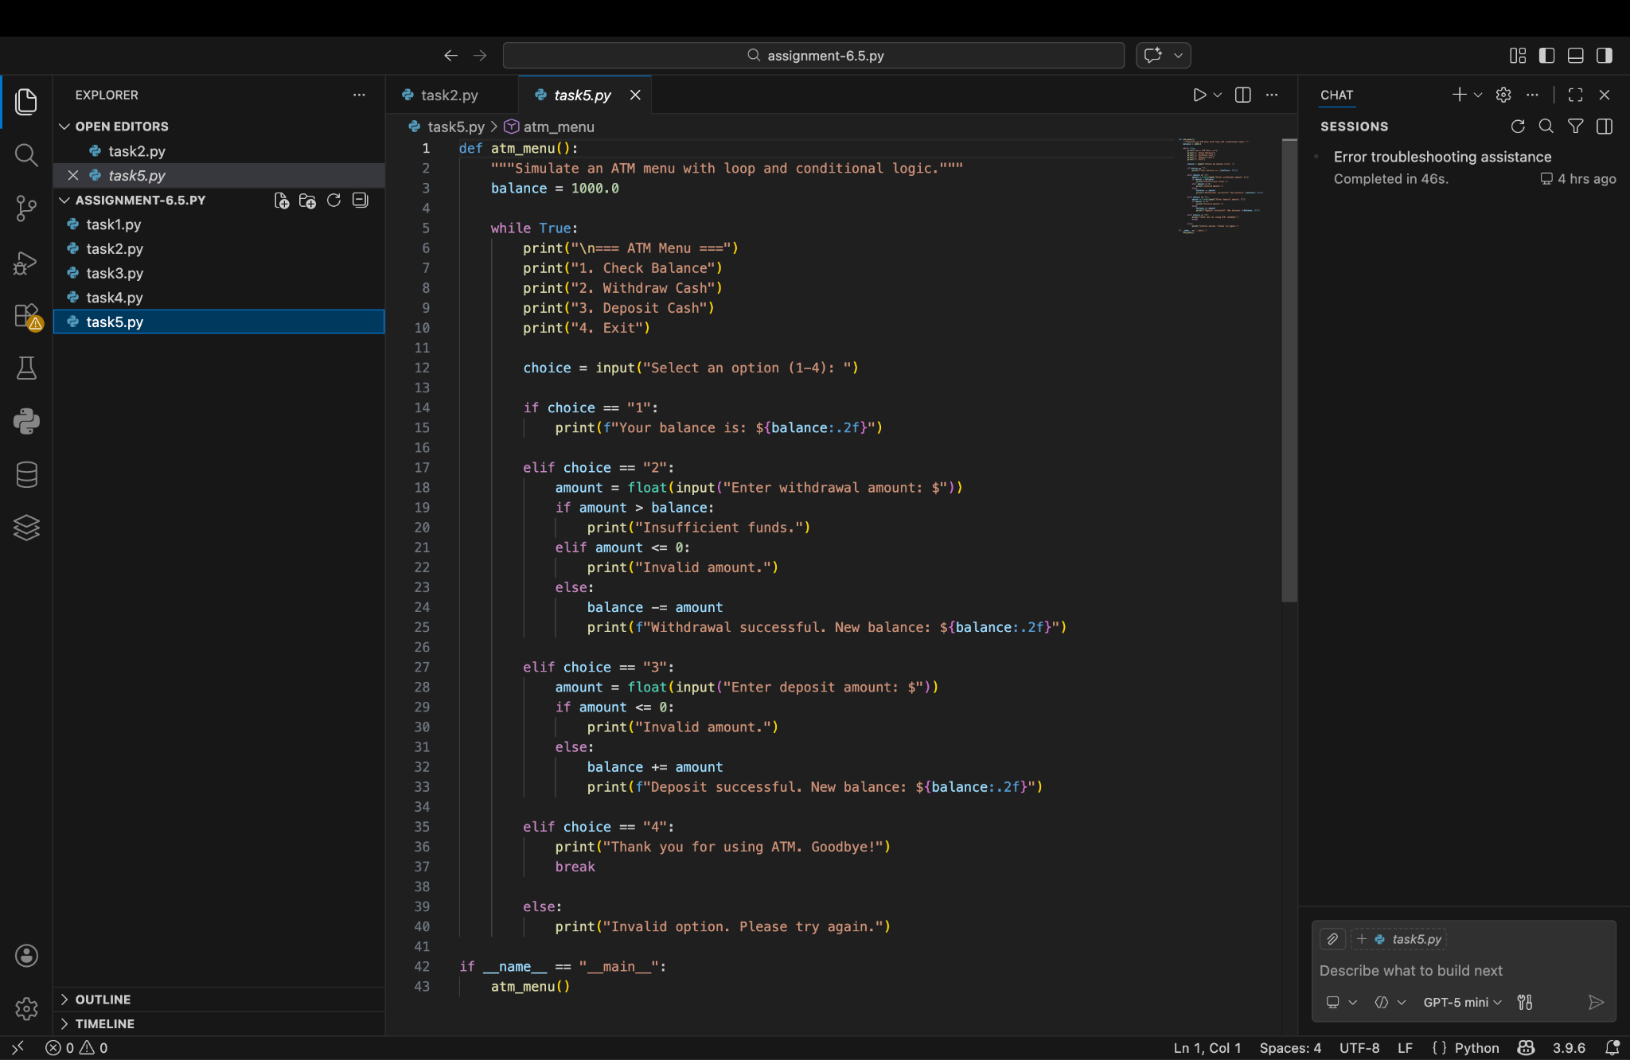

Output:
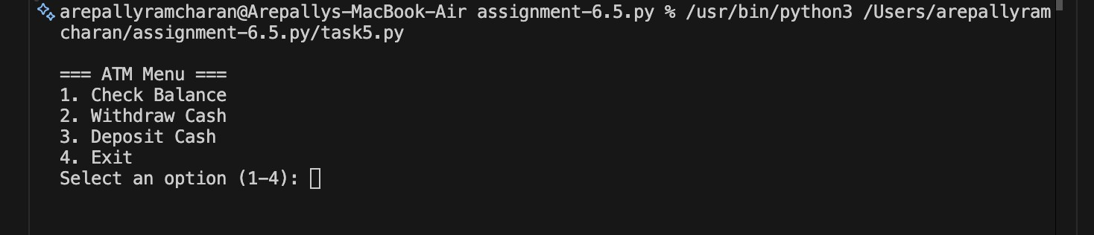
Observation:
The AI-generated Python program simulates an ATM menu using loops and conditional statements to handle user navigation. The menu repeatedly displays available options such as balance check, deposit, and withdrawal, allowing continuous interaction until the user exits. Conditional logic ensures that each selected option is processed correctly and invalid choices are handled properly. Output verification through different test inputs confirmed that the menu logic works accurately. This task shows that AI-assisted code completion is effective for building menu-driven programs with reliable control flow and correct option handling.

